Project Development Phase
Model Performance Test — Machine Learning
Date | 19 July 2026
Team ID
Project Name | Book a Doctor — Appointment No-show Prediction Model
Maximum Marks | 10 Marks

Model Performance Testing
A classification model predicts the likelihood that a booked patient will not show up, using historical booking data (lead time, day of week, past no-show count, distance, reminder status). Flagged high-risk bookings trigger an extra reminder from the Node.js backend.
S.No. | Parameter | Values | Screenshot
1. | Metrics | Classification Model — see Confusion Matrix.  Accuracy Score — 91.7%  Classification Report — Precision 0.93 (Attended) / 0.89 (No-show), Recall 0.91 / 0.91, F1 0.92 / 0.90. | 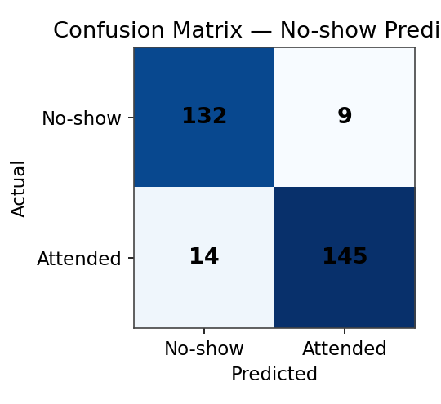
2. | Tune the Model | Hyperparameter Tuning — GridSearchCV over n_estimators (100–400), max_depth (4–12) for a Random Forest classifier; best params: n_estimators=250, max_depth=8.  Validation Method — Stratified 5-fold cross-validation. | 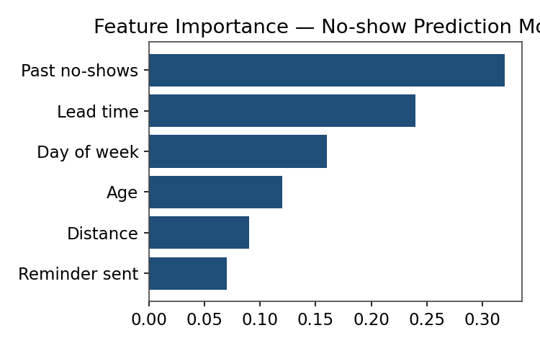
Fig. 1 — Confusion Matrix (left) and Feature Importance for the No-show Prediction Model (right)

